My thoughts on some perennial economic topics of India :

### Q. How does the rise in inequality distort Indian society?

Originally answered here: <https://qr.ae/pND8Oj>

Wealth/Income Inequality is not necessarily a bad thing. However, there are some consequences of these that make the society unstable. IMO campaign against “wealth inequality” should actually be a campaign against excessive “gatekeeping/rent-seeking” behavior. Gatekeeping/rent-seeking is when the privilege induced by wealth inequality starts translating into suppressing fair competition and meritocracy. The distortion in society you attribute to wealth inequality is actually created by the . However, “end wealth inequality” makes a better political pitch and hence everyone gets on-boarded onto that wagon.

Wealth Inequality has its advantages too. It creates many able people who can take risks to do innovation rather than a single entity {state in communism} say. When a single entity does innovation [in science, business, technology ] on part of entire population, just one failure could make the entire system crash. Many individuals tinkering things gets a lot of innovation into the system without the risk of failure. The more innovation is, the more possibility of creative disruption and wealth redistribution to new people. This is one of the core premise of Stephen Pinker’s book Enlightenment Now. {Must read btw, I liked it a lot}.



Stephen Pinker shows that liberalism [earlier classic liberalism which evolved into neoliberalism] which evolved from renaissance ideas has been making human life better everyday statistically, despite many of us thinking otherwise.

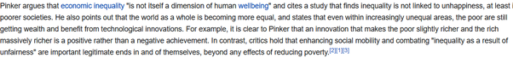

We have seen inequality in the world rise and still humans getting a better life each progressing year. So technically, its clear that inequality is not bad directly.

However, gatekeeping does come up as a side effect of inequality. This is something that Professor Pinker doesn’t talk about in his book a lot, but one cannot deny such a thing. So for example, a rich person may use their contacts to influence behavior away from a less rich person. In more brute terms, this would be done by just overriding “meritocratic” criteria {like how its shown in legendary scene of movie Deewar, “I am sorry, the other candidate knew someone who knew someone, we cannot give you the job” } :

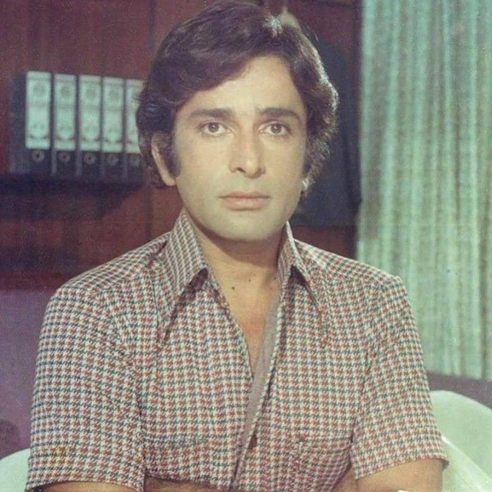

Or more cleverly changing the meritocratic criteria to something the poorer person cannot afford. So new criterion added for qualifying jobs, which specifically the less fortunate cannot afford to get good at. In movie Deewaar, the job was a clerk, but think of such things happening in jobs in administration and bureaucracy.

The same thing could happen with government and private contracts, honors, scholarships and many other things reducing the power of someone who is less rich than the other. Merit can be overridden with credentials quite easily and most people would continue to think they are in a meritocracy while they are playing a rigged game. And then one day common people suddenly wake up to the reality and would want to change society overnight making things worse for all.

The other thing that can be used to “gatekeep” is fear. They know that the risk tolerance of the poor masses is low, so if they can make anything which is good for the masses more fearful than it actually is, the poor masses would deny the advantage despite of all the positives. Indians have been kept away from entrepreneurship and businesses by Indian Communist intellectuals [who despise themself as rationalist] portraying business as bad and stock market as sin and economy as something driven by import-export. We might laugh at it as it sounds like conspiracy theory, but ask a common man and he is still skeptical of private companies and trusts government and its slow bureaucracy more. Indian middle class came out of this mindset after the 1991 economy liberalization, but our poor masses and traditional industry like agriculture workers are still stuck in this mentality. Inequality doesn’t distort the society, but when software engineers are making 21st century salaries and farmers get low money like 1980s for their products, software engineers will have much more risk appetite and be able to take risks. Unfortunately, a lot of “experts” in the country think that sticking to the status quo is better than letting farmers take some risk of market economy.

There are many ways to address [not avoid] these situations like how different countries are solving it :

A. Welfare state like in Europe.

B. Cultural defense like in the US. US has a cultural orientation to achieve C below. Whether the cultural thing works or US moves towards A is still to be decided.

C. Tying the incomes of poor and the rich in some way through government policy or molding national culture to achieve it so that one getting strong means other getting strong too like in Taiwan and China. China is a mixture of A and C.

[What I feel is a good way to achieve it in India in future would be a mixture of A, B or C depending upon which among US and China is the world power in future and our own situation ]

We now know three things :

1. Societies which prospered have had inequality. There should be better off people who can take different risks bringing about innovation.
2. However, inequality can lead to rent seeking in things outside money which can sometimes make common people dissatisfied. Dissatisfaction makes society unstable. Basically few people are jealous of another person’s wealth, but most feel bad if the rich person uses their wealth [or influence of wealth] to get ahead in things where they feel the rich person is not as good.
3. Another thing inequality creates is different risk appetites of rich and poor people. If something that makes good money for poor can be somehow shown to be risky, the poor would willingly give it up, letting the rich take all advantage of the proposition.

Let us now understand the Zero Sum game that people associate with inequality [and why its irrelevant in the current world].

Basically in a capitalist system, people assume :

Earnings - expenditures - Wages [Labor Income] = Profits [Market Income]

Now since everyone is greedy [something on which communism and libertarian thought agree] , the only way to make more money is increase earnings [so expand the market of the country to abroad], reduce expenditures [get cheaper machinery and land from whosoever offers it at the best price] and when both of these saturate, workers and shareholders would on opposite ends as one would try to increase the Labor share [wages] and the other will try to maximize profits [profits]. So when the economy reaches a saturation point, workers and investors are shown to be fighting in a zero sum game where rich grow richer by taking away poor persons’ wages. BTW, that is not totally false when we look at the times of industrial revolution in England and Europe. [Working and Living Conditions](https://firstindustrialrevolution.weebly.com/working-and-living-conditions.html)

. The entire philosophy of Communism came out of this ill treatment of workers. There is no doubt that the workers need enough money to survive at the least, by survive I mean [Food, Shelter, Health, Education], if a capitalist system cannot provide that, it would collapse like in 20th century Russia or China. So if a capitalist system is surviving, it has at least found a equilibrium where workers don’t have to worry about “survival”.

This “model” of inequality, however, is now redundant because : A. Most first world countries have removed need to worry for survival and developing countries are quickly following them. B. Most new capitalist wealth [specially in big tech is not being generated by dividents/profits but by growth investing [Growth investing - Wikipedia](https://en.wikipedia.org/wiki/Growth_investing)

].

Indian worker is not one defined person, there are people living in pre-1990s socialist India in some industries [with socialism level ‘according to their needs’ low wages] and there are people writing blockchain as well. This actually creates a very different income distribution, which should be India’s primary aim to solve. ***India still has to complete solving problem of providing everyone with necessities before we focus full on solving a first world problem like “income inequality”.*** If we are unable to bring all sectors of economy in the same economic system soon, we will have to solve dual problems of income inequality for some segments of society and survival for other segments. We are lucky to blessed with an growing economy so that these problems are not pinching us hard right now, but we should build policies which aim to achieve equilibrium during the period of high growth.

We are not doing bad btw :

[Report: India Lifted 271 Million People Out Of Poverty In A Decade [Infographic]](https://www.forbes.com/sites/niallmccarthy/2019/07/12/report-india-lifted-271-million-people-out-of-poverty-in-a-decade-infographic/?sh=44d7ec262284)

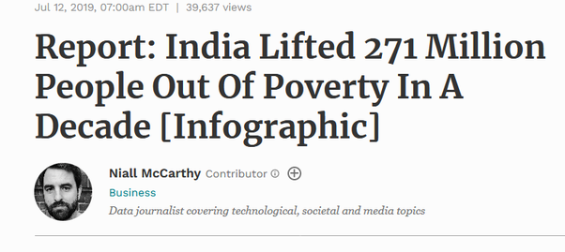

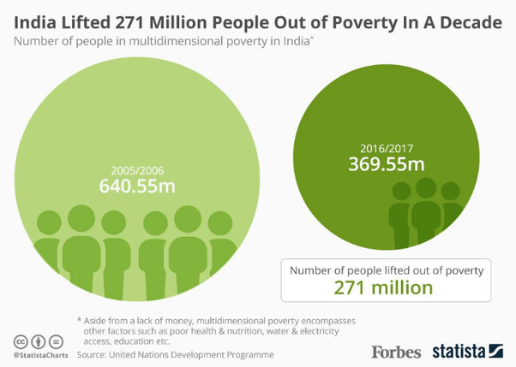

With new reforms being introduced in traditional sectors of economy, you should think that India will eventually have a structure like the west has today and China is soon approaching :



But what about eventual capitalist systems where all economies eventually reach, where workers are earning enough to not have survival issues ? Where should workers invest the extra cash they earn ? Should there be worker protectionism [say minimum wage or protection of traditional industries] or workers need to look after themselves? Are the workers supposed to create a moat just like investors do ? When in a society people are earning enough to live, the next question is where do they spend ? While most investors will hardly indulge in spending just for the heck of it and will invest their money, workers are encouraged to buy stuff. As J J McCullough says, middle class [which is now the default worker class in OECD] is based on three proponents :

[https://youtu.be/OsUEbN6NZr0](https://youtu.be/OsUEbN6NZr0)



These words might sound bad, but they are not . “Anxiety” is basically the push that makes people work hard to make sure their family continues to have a good living. “Consumerism” is buying things to make life better for family and “Conformism” is doing what rest of middle class is doing to make life better.

***How India will build the new culture of its upcoming middle class around Consumerism and Conformism will define how we solve the problem of inequality.*** We would either go the China way or go the Scandinavian/Russian way or the West Europe way. Referring to observations of the paper [Capitalist Systems and Income Inequality](https://stonecenter.gc.cuny.edu/research/capitalist-systems-and-income-inequality/)

going forth.

Please look at the following curve, India lies with other “developing economies” like Mexico, Brazil etc in the fourth Quarter. This basically means we are still a partially traditional economy and partially modernized one. [Only somewhat modernized economies listed here].

The Y axis is proper wealth inequality [compositional inequality or Mathematically Gini Index, Y=1 means all welath with one person and Y = 0 means everyone with same money] and X axis basically tells if the “source of income” of rich and poor are the same or different. [1 being totally different]. Right now India’s rich primarily make money from investing in stocks, real estate and other safe financial instruments while poor make money by selling their time on agricultural fields and workshops, so its near 1 from India obviously if you have been reading my answer.

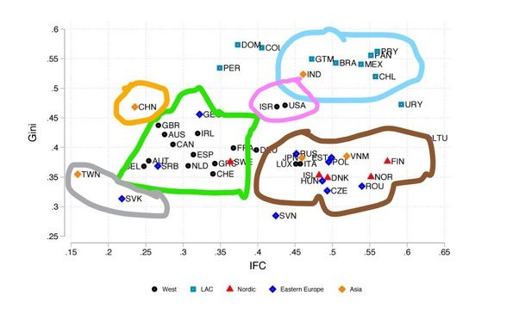

You can see clusters of countries, like West Europe in Green, East Europe and Scandinavia in brown cluster, Taiwan and Slovakia in a unique cluster and China in its unique cluster and Israel and America in one. East and West Europe clusters depend upon welfare state to address inequality. I think with the free market type approach India now has, it would eventually reach a US like situation [mixed consumerism/investing culture]. For China like situation, India would have to mandate workers [or create a culture] to spend in a way that mirrors how the rich spend their money [Investing in low but non-zero risk financial products and not consuming goods with all the money they earn] .

### Q. What if India would be full of foreign companies and no Indian company?

Originally answered here : https://qr.ae/pNaHms

It won’t be possible to have no Indian companies at all. A nation cannot just be a market (like what happened during colonialization) or a market+sweatshop (like how people would imagine a situation like this to happen in modern world) forever. Let’s discuss both these scenarios :

**Colonial Times (Colony is just a oligopoly market for foreign companies):**

One cannot eliminate all Indian companies even during colonial rule, you would always require help of local entrepreneurs and businessmen. There were many British business owned stooges in India during colonial times. So even in a colony, there will be either subsidiary companies or suppliers despite we trying to push out all Indian companies. But we have had an extreme low of influence of Indian businesses in our market.

The closest to having no local companies and only foreign company India reached was during the British colonial rule (and the East India “Company” rule before that). Not all the companies and businessmen were British or European, but most of the important ones were. Regulations and tariffs were used to not just pay Indian merchants with money extracted from Indian farm revenue thus making India’s money supply low, but also there goods were made less competitive so that they could not compete in Europe or even in India.

India’s cotton businesses were for example forced to close to keep only British businesses in the European and even Indian market. [Textile manufacture during the British Industrial Revolution - Wikipedia](_blank)



Cotton made Bengal probably the richest province in India and once it lost its trade advantage, the money supply to Bengal was greatly reduced. Similarly, Indigo, Salt and other exports of India were actively thwarted and India’s gold was taken away as British company’s were more competitive than Indian counterparts due to regulation. Think of it, buying a product made in UK was cheaper than local Indian products. [Economy of India under Company rule - Wikipedia](_blank)

So an extractive economy where British Government could make laws to make British companies more competitive essentially did wipe out Indian companies. Let’s talk about Bengal in particular, Bengal had a better per capita income pre-British conquest than all of Europe and Britain itself. It was possibly more industrialized too. In a few centuries of trade deficit and many man made famines ([Great Bengal famine of 1770 - Wikipedia](https://en.wikipedia.org/wiki/Great_Bengal_famine_of_1770)

, [Bengal famine of 1943 - Wikipedia](https://en.wikipedia.org/wiki/Bengal_famine_of_1943)

) , it was poor super densely populated Indian state (due to its poor populations from erstwhile industrial nodes and their supply hinterlands) which had to move to a desperate measures like communist governments to keep the society from falling apart from lack of wealth. There is a reason India went full “no to international trade” during 1947–1991. I don’t think I need to explain why India will not want to become a colony anymore.

**Modern Times (Less income countries are markets + sweatshops for large first world companies)**

In modern times, an alternative way is possible to reach close to the theoretical point of having no local companies at all. That way is for a low income company to become a sweatshop for companies of first world companies. First world companies have high labor rates so they enter low income countries to manufacture. This manufacturing capability can expand to make prices of their product/services much more competitive/high quality to enter markets of third world country too, eliminating companies serving third world countries. Rising incomes in the third world country would make more foreign countries rush to cater the demand of middle class as the local company ecosystem for this country would have been shrunk to give a credible competitor.

This process is not at all bad for the third world country btw. Incomes rise, People come out of poverty, good quality products are available for cheap. Adam Smith’s “The invisible hand” profits both parties involved. India has lived in this type of a bubble during 2000–2012 say. [Economic development in India - Wikipedia](https://en.wikipedia.org/wiki/Economic_development_in_India)

. You can say some phase of this continues even today. Everyone loved working at Microsoft and eating at McDonald’s during this time. (I remember this too well as I joined workforce around 2012, when the trend had started dieing after the world had witnessed 2008 economic downturn). There are proponents of opening up many other guarded sectors of Indian economy to free trade to let incomes go up even more. An Indian milkman still earns much less than say an Indian who does Data Entry in a IT company. There is some action on it too, where Indian government keeps relaxing FDI limits for different sectors. One can thus surely ask, why not just go all in on full trade ? just let incomes rise, we loose business capabilities locally but large companies sure employ many people with more sturdiness to cycles of economic downturns. A job in a large MNC is safer than a job at a startup.

The reason is perfect efficiency (absolute free trade in this case) is good in short term and can be used to increase income and competitiveness, but is not really a good long term strategy. [Muktabh Mayank's answer to How far can India go to keep the Chinese players, who are well en-trenched in the global tech supply chain, off the Indian market without prejudicing its own growth?](https://www.quora.com/How-far-can-India-go-to-keep-the-Chinese-players-who-are-well-en-trenched-in-the-global-tech-supply-chain-off-the-Indian-market-without-prejudicing-its-own-growth/answer/Muktabh-Mayank) . While the linked answer of mine is more theoretical, I will give a practical example of what happens if we let free trade fully take over, where world leader MNCs are sure to beat out local Indian companies in terms of quality and price (or both). {If you think on lines of ohh, Indian companies should step up and compete against these giants, why give them a break, read my answer here: [Muktabh Mayank's answer to How does a company that sells a powerful software package like MS Office survive when others offer a free equivalent package?](https://www.quora.com/How-does-a-company-that-sells-a-powerful-software-package-like-MS-Office-survive-when-others-offer-a-free-equivalent-package/answer/Muktabh-Mayank) . TLDR is that a business with better ecosystem and knowledge advantage cannot be defeated most of the times. We need to help our local companies stay competitive while avoiding building a monopoly for them. }

So, the problem with the countries which took this model of being just a market and a sweatshop killing local companies to the extreme is eventual [Middle income trap - Wikipedia](https://en.wikipedia.org/wiki/Middle_income_trap)

. No doubt the per capita income goes up by a lot and that too comparatively faster than developing ones own industrial/business ecosystem (China is quickly disrupting the narrative of indigenous ecosystem based development is slow btw) . Major case studies for such economies are 1. Thailand and 2. Brazil. Thailand is very interesting. [Economy of Thailand - Wikipedia](https://en.wikipedia.org/wiki/Economy_of_Thailand) is one of the best economies of Asia. It has decent per capita income (much better than an average Asian country) and even a welfare state. It is a manufacturing base of cars, electronics and jewellery. Do you know of any Thai car companies ? No. Most of these are MNCs. Luckily the tourism sector of Thailand is innate and cannot be really a fully foreign run sector like agriculture sector of India. Look at its neighbors and Thailand dwarfs them economy wise just moving with and supporting free trade. Probably a mini model of what a India moving on similar lines would look like. What is the harm in being like Thailand you ask ? No ecosystem to take them ahead of where they are now. They have a huge sovereign fund which they can probably use to fund their people, but there is a very small software ecosystem, a very small deeptech ecosystem, a very small startup ecosystem (say compared to much poorer Indonesia: [7 Best Famous Startup Indonesia](https://www.mime.asia/7-best-famous-startup-indonesia/) ) , the things that would drive the future of growth. People have been engaged in industrial manufacturing jobs that suffered a jolt due to the pandemic and launch of electric vehicles. Tourism went down due to the pandemic and now you have widespread social unrest. [Tensions Mount In Thai Protests As Bangkok Braces For Major Rally](https://www.ibtimes.com/tensions-mount-thai-protests-bangkok-braces-major-rally-3087932)



When people don’t see growth in their personal lives they get frustrated with authority. This is how classic Middle Income Trap works. Look at Brazil and you will see parallels too.

**Conclusion:**

OK. That’s what I wanted to say, not having local companies reduces chances of people being lucky and getting rich. In colonial times, it was also accomplished by abject poverty. In modern times, not having large local business ecosystem doesn’t make people poor, in fact they start doing better quite fast. However, with this stability/peace of mind, it also reduces risk-taking capability. As Zuckerberg says, “Biggest risk is not taking any risk at all”. [How Mark Zuckerberg thinks about risk — and what you can learn from it](https://www.policygenius.com/blog/mark-zuckerberg-facebook-risk-advice/)

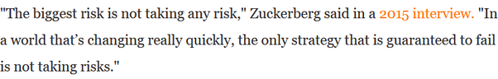

Risk of automation, stagnation and social unrest comes with middle income trap. A later generation pays the price of one generation’s risk aversion.

### Q. How can we evaluate the success story of Bangladesh in the recent times which is transforming towards a fastest growing emerging economy from the status of a poor country? Is there anything which India need to replicate?

Originally answered here: https://qr.ae/pNiVrQ

Good Question.

Let’s try and understand that Bangladesh and India have always been neck to neck in growth rates. Its not a sudden spurt of genius on part of Bangladesh and misadventure on part of India that has lead to a switch. Look at the timeline, Bangladesh has been chasing India’s growth rate and the gap had been going down for a long time, until it overtook India.

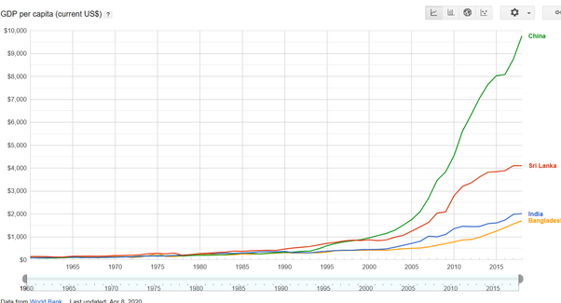

Let’s answer the question why has Bangladesh done so well ? Textiles and cheap manufacturing is the answer. Specially Textiles. Clothes and ready made goods are such a huge market that they keep economy of Bangladesh and Sri Lanka (also some tourism) and to some extent Pakistan afloat alone.

[Textile industry in Bangladesh - Wikipedia](https://en.wikipedia.org/wiki/Textile_industry_in_Bangladesh)



Think of it, Undivided India (which is today’s India and Bangladesh and Pakistan) was the textile super power of the world and textiles had made GDP per capita of Bengal (Now Indian state of West Bengal and Bangladesh) larger than Europe and in fact UK, our then to-be colonial masters. British rule had almost destroyed our industries (textiles and otherwise), but with UK going into war production during world war 2, they revived somewhat to meet local demand and there was a boom post independence.

India continued to make its textiles industry more and more noncompetitive in the international market and Bangladesh took full advantage by introducing market reforms. Bangladesh’s ready made garment exports are larger than India and even China !

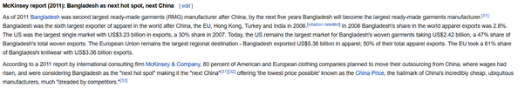

Indian farmers produce enormous quantity of fibre, but our textile production is extremely low (4% of the world). Many branded clothes you wear even in India come from Bangladesh despite us growing huge amounts of fibres. Indian textile industry failed to continue to be competitive. [Textile industry in India - Wikipedia](https://en.wikipedia.org/wiki/Textile_industry_in_India)



So what was the problem ? Why did Indian textiles loose the status of a behemoth and we lost the race in this lucrative industry ? Being resistant and unprepared for change is the answer. While there is a certain cosiness and comfort in a booming industry, we need to make sure that we are reinvesting enough to keep it relevant and competitive. That generally is something people don’t see in the middle of the boom.

**India failed to move its textiles industry to hinterlands :**

When an industry is at its zenith, the wealth it creates might start pushing it into being less competitive. India’s textiles were situated in large cities like Mumbai and Surat and the like. They then moved into lower cost Dhaka and China. Why not say Kanpur or Patna or Cuddappah ? India was so busy eating the fruit of its successful manufacturing (sweet tax and forex dollars !!) then that it forgot that you don't slaughter the goose laying golden eggs.

**Socialism became Stagnation-ism :**

While Socialism is good for people (some version of it which I subscribe too :D ), but the obstructionist version of it is just a drag. I mean just look at difference between India and Bangladesh’s attitudes towards strikes. Strikes basically mean workers topping work if demands are not met. Not saying the attitude of Bangladesh was good, using police power to crush the resistance to production : [Textile industry - Wikipedia](_blank)

.

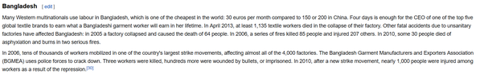

But Bangladesh has stayed to stay competitive and that is all probably all that matters if we look at everything from the lens of GDP per capita. Different people can have different opinions about whether poor working conditions are better than abject poverty. In India however, our politicians forced the entire textile industry in Bombay to close down losing jobs of everyone than working in poor conditions. IMHO, there should have been a middle path where we could have thought of a way in which both textile industry and workers compromised a bit, textiles survived and workers got slightly better working conditions at the same time, but well I dont think you can make a movie on it (with a Che Guevara like poster) : [Albert Pinto Ko Gussa Kyoon Aata Hai - Wikipedia](https://en.wikipedia.org/wiki/Albert_Pinto_Ko_Gussa_Kyoon_Aata_Hai)

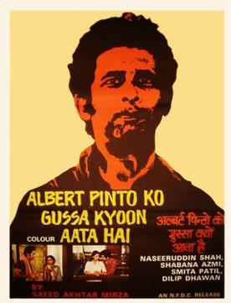

Read more here : [Great Bombay textile strike - Wikipedia](_blank)

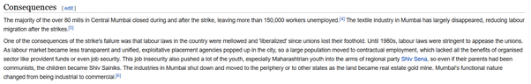

**India’s apathy towards manufacturing :**

Post 1990s’ economic liberalization, India went into a Neoliberal Spree. Even if India produced cheaper textiles, our people would have purchased American or German (which would have been manufactured in China/Bangladesh). India might get some of our manufacturing back with the recent [Make in India - Wikipedia](_blank)

trend, but at least in a huge sector like Textiles, at best we can hope for is to sell our textiles locally, we are too behind and non-competitive to see a global export dominance anytime soon.

The most important part, Lessons from Bangladesh:

**Manufacturing (and other traditional sectors) is still huge, don’t discount them:**

India has its romance with software and services, but manufacturing and other traditional sectors of economy are still huge. Bangladesh could defeat us in GDP per capita by just dominating one traditional industry.

**Ecosystem needs small changes to stay competitive :**

The industries which are competitive right now for India should now just be looked on as cash cows. We need to make them more sturdy towards changes. One trick I can think about IT industry was to move it to tier2/3 towns by building good infrastructure for them in such towns. India is such a huge country with such economic disparity that no industry can ever become non-competitive.[Muktabh Mayank's answer to How is India's Information Technology (IT) industry likely to evolve over the next 25 years? Or is it going to flicker off and extinguish?](https://www.quora.com/How-is-Indias-Information-Technology-IT-industry-likely-to-evolve-over-the-next-25-years-Or-is-it-going-to-flicker-off-and-extinguish/answer/Muktabh-Mayank)

Bangladesh’s rising per capita income will soon put its textiles industries in same situation of stay competitive or GTFO of Dhaka. Bangladesh would want to make the industry stay in its hinterlands than letting it move to Mandalay or Rakhine in the nighborhood.

**While of course people can worry about their finance today, they also cannot be too complacent :**

One incident from today that reminds me of the downfall of textiles industry is ongoing farmers’ protest from state of Punjab in India. Punjab traditionally has been India’a wheat basket, but they cannot assume that with them refusing to take up efficient procurement/market practices within India, India will be forced to look outside for grains (people cannot go hungry) and we are going to through the textile industry route with farming in Punjab. The best case IMO scenario for India and Punjab is : “Other states of India continues its dependence on Punjab by giving Punjab agricultural goods preference over international, getting them good prices and Punjab embraces the free market practices the rest of the nation has and efficiency of national supply chain goes up”. Not trusting the rest of the country is not going to go well.

Unfortunately, this makes for a poor pitch politically as compared to surrounding Delhi roads and obstructing supply chain infuriating the urban natives who actually make policy ! Suggesting changes in farming reforms is one thing, demand of rolling reforms back or the national capital will be chocked for a few months is a different thing.

[Farmers plan Delhi siege to protest farm sector reforms](https://www.deccanherald.com/national/farmers-plan-delhi-siege-to-protest-farm-sector-reforms-919535.html)



### Q. Do you think healthcare and education merit more spending to make India's economy immune to future shocks?

Originally answered here : https://qr.ae/pNl3Y5

It’s a very broad question and my short answer is “Spending money with good RoI will be helpful, but not just ‘spending money’ for the heck of it”. I also think that we Indians need to think of healthcare and education from an innovation point of view rather than just spending assuming the current western systems are the right ones, we are solving these problems at a much bigger scale than any western country does.

Looong subjective explanation below :

Do you really think India’s spending on these sectors is less ? 11 Rupees out of every 100 rupees spent in India are directly spent on healthcare and education. There is also a lot of money spent on infrastructure and transportation, like roads and transport that makes these amenities possible.

[Muktabh Mayank's answer to Where should the Indian government invest more money, defense or healthcare?](https://www.quora.com/Where-should-the-Indian-government-invest-more-money-defense-or-healthcare/answer/Muktabh-Mayank)

India spends a lot on healthcare , around 150 Billion Dollars every year. Our total GDP is < 3000 Billion dollars. So for every 100 rupees spent in India on every possible aspect, 5 rupees are spent in healthcare. When you suggest increasing spending in healthcare, you are essentially advocating one of three things :

1. Increase total size of Indian economy, as a result, many healthcare expenses that people cannot make as of today {say on mental health}, would become more accessible, raising the healthcare spending more. ***I hardly think anyone is against this.*** There are many places where India’s poor would rather not approach a doctor when the immediate risk is relatively lower and healthcare would become more accessible as they get richer. By all means, our people should get richer and have a more comfortable life having amenities they don’t have now.
2. Government investing into the healthcare sector, subsidizing some of the essential healthcare temporarily till economy of scale is achieved. You can see this happening in [Ayushman Bharat Yojana - Wikipedia](https://en.wikipedia.org/wiki/Ayushman_Bharat_Yojana)

and [Pradhan Mantri Bharatiya Janaushadhi Pariyojana - Wikipedia](https://en.wikipedia.org/wiki/Pradhan_Mantri_Bharatiya_Janaushadhi_Pariyojana)

1. . This is taxpayers money subsidizing healthcare for masses making them physically fit so that they can eventually work towards a better economic profile where they can take care of themselves. This type of government spending is a double edged sword, as it does provide impetus to make a robust and scaled up economy, but one needs to make sure that the goal is not always to fund bottomless loss making black holes. Democracies often go overboard in such circumstances to win elections ! People generally expect the money systems to lead to circumstances like mentioned in point 1 above, but government and institutions many times nudge people into point 3 below because of the amount of power it concentrates. For countries with low individual incomes like India, having spending to ensure public accessible healthcare is important and that is the reason there is a considerable public spending towards accessible healthcare in last 10–15 years. India despite of all negative portrayal it gets has one of the most accessible public healthcare systems in world. [See Guardian article below]. ***Most political centrists {which is most of the people} would like this approach [A private + public healthcare combination to secure both accessibility and quality]. Very libertarian people might not like it.***
2. The third is a Europe style fully public healthcare sector with taxes levied on everyone to fund a agency like NHS. Many people who complain about low healthcare spending are basically complaining about “low government spending in healthcare” and not “low spending in healthcare in total” and they are basically asking for a state controlled healthcare. Basically, “Experts” decide who gets to visit which doctors and when and what medicines can the doctors prescribe. As you might be clearly seeing, leaders, executive and government have too much power here. Getting to decide fully how to spend whole of country’s healthcare money is too much power, which can be exploited. ***Its a matter of personal opinion whether people trust their ruling elites and experts to make all healthcare decisions on their part and naturally a lot of them will disagree on this.*** IMO, Private competition is always good for public firms, public firms do not need to compete in terms of profitability, but they should at least be competitive in terms of quality. In countries of Latin America and many other parts of the world, you see leaders politicizing their spending policies leading to bloated and below standard public money suckers. *Many leaders who pitch “great” , ”free” healthcare to you often have this plan in mind. As is obvious, this would a dividing topic.*

['This scheme is a lifesaver': India's drive to provide cheap drugs | Amrit Dhillon](https://www.theguardian.com/global-development/2018/jun/25/this-scheme-is-a-lifesaver-india-drive-to-provide-cheap-medicine-jan-aushadi)

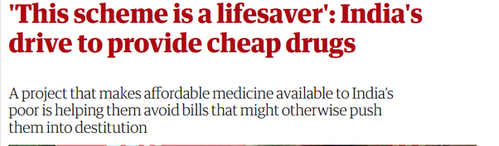

Education sector is even larger :

[India’s education market to nearly double to $180 bn by 2020](https://www.vccircle.com/indias-education-market-nearly-double-180-bn-2020-1/)

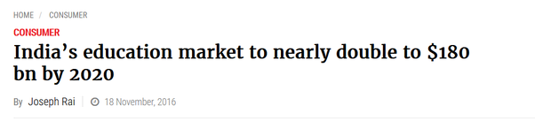

This is 6 rupees out of every 100 rupees spent in India. Not a small number. Just like healthcare, its not all government spending. Individuals can choose what schools they want to send their kids to [and that can be public schools and private schools] than government taking money as taxes and allocating your kids to a school they think is more suitable for your kid. I guess to a certain extent, just like healthcare, we all can agree that there is a minimum amount of expenses that the country needs to do to train its Human Resources. ***There is a common ground on having some public spending to look after the less fortunate and other people having a choice to get the best education possible for their kids.***

Just like in healthcare, Many people complaining of “low spending in education” are complaining of “low government spending on education”. Basically government setting up education norms and schools for everyone. I need to see examples of a successful and fully funded public education systems to believe this is something that would work. One pilot project of a school with swimming pool and horse-riding and snooker table is different than burning public money maintaining this quality across all public schools of a country. This asymmetric spending {much more than what one can afford personally} will also put small private schools out of business as it sets unnecessary standards on education, making private education more costly, making people rely more on public schools. As I said, public spending is a double edged sword which can enhance or break economy. The aim is to keep public spending to keep public institutions competitive to private ones, not blow the private institutions away. If we do latter, we would have a education scenario like healthcare scenario 3. A lot of people won’t like that.

***Net net, as long as spending on healthcare and education is “justified”, I guess most citizens will have no objections to such expenditures and some increase in them.*** Just that different people have different definitions of justified. A lot of them think that horse-riding in schools is necessary and others think a good science education is all that we need. Similarly, some people will think that having a dermatologist in every village is necessary, while others think a functional basic healthcare center is good enough.

IMHO, as long as the spending is being done as an investment which will pay the nation back as healthy, scientific and analytical citizens, it is “justified”, the day its done just as a decision to win votes, it makes a economic black hole. Being immune to shocks doesn’t involve being more “prepared”, but rather having less “bloat” and being “agile”.

How to be spectacularly wrong.  
The October 2019 predictions of preparedness for epidemics turned out to be entirely unrelated to the actual outcomes.   
My new post.<https://t.co/HyIWRW8F5m>

— Branko Milanovic (@BrankoMilan) [January 23, 2021](https://twitter.com/BrankoMilan/status/1353031522207621121?ref_src=twsrc^tfw)

You can never be prepared enough against a “black swan” event like a pandemic, all you can do is to minimize tail risk. In economics, tail risk is stagnation and low return on investments. Doing any investment which will give poor return on investment is basically making oneself {or in this case the country}, more venerable to shocks.

Lat but not the least, I think we need to start thinking of the fact that no western country has solved the problem of healthcare and education, so we need to stop looking towards them for giving use ideal models to follow. What we Indians need to do is to figure out an education/healthcare model for 21st century India where we are solving it for over a billion people. The important keys in this area are internet, smartphone penetration and creative disruptions by startups to address supply demand gap or scale up quality supply. We Indians can actually better the quality of public services without really spending much if we can innovate our challenges away.

[Muktabh Mayank's answer to Are critics being too harsh on EdTech start-ups in India?](https://www.quora.com/Are-critics-being-too-harsh-on-EdTech-start-ups-in-India/answer/Muktabh-Mayank?ch=10&share=2eba20be&srid=qie)

### Q. What problems could India face because of the rupee not being backed by gold?

Originally answered here : https://qr.ae/pNJvgu

Gold Standard was a strange concept even when it was in practice. It was being used because due to the slow spread of information, it was the only option {if you don’t think Silver Standard was a very different thing from gold one like me}. From [Gold standard - Wikipedia](https://en.wikipedia.org/wiki/Gold_standard)

:

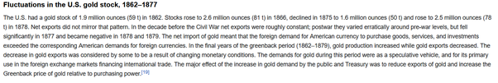

It led to strange fluctuations in currency values and basically reduced the monetary power government had. In times of bad economy like pandemic, war or depression, gold standard made things much worse. {It’s hard to extract directly from people who are already in bad times to revive economy, QE is a necessary evil in bad times ! }.

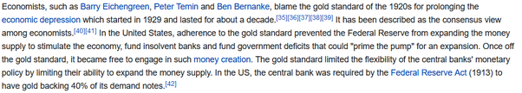

Excess of QE is what a government can resort to in absence of Gold standard. That is possibly one of the greatest mistakes governments make yielding hyperinflation. India however has a monetary policy of stability primarily, avoiding any dangerous adventures. [Monetary policy of India - Wikipedia](https://en.wikipedia.org/wiki/Monetary_policy_of_India)

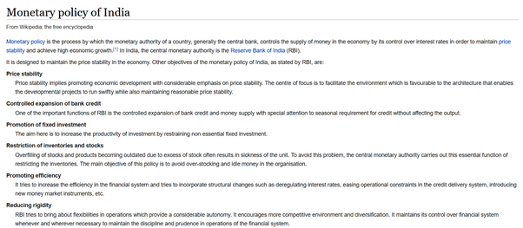

### Q. What's elder people's reaction to times when you could buy the entire month's ration in 1 rupee to today where you only get a toffee for a rupee? Is the inflation worth it?

Originally answered here : https://qr.ae/pNJvGD

“Is the inflation worth it ?” Of course ! In any sense, India of 21st century is better than India of 20th century {much better than India of 19th century}. A colonized country, whose currency was forcefully pegged to British Pound to facilitate trade in pounds and not changed according to its local requirements, can have a costly currency, but had really poor, malnourished people. [I will share one specific instance about the 1880s in the answer].

[Gold standard - Wikipedia](https://en.wikipedia.org/wiki/Gold_standard)



No country should have an economic {monetary/physical} policy like Argentina in 20th century and Zimbabwe. Crazy crazy inflation :

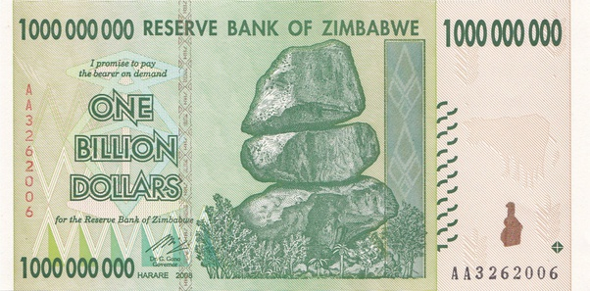

But that said, having no control over monetary/fiscal policy is equally bad too !

India in 19th century and first half of 20th century was a colony whose main aim was to enhance British financial position and power in the world and no better. [Muktabh Mayank's answer to What if India would be full of foreign companies and no Indian company?](https://www.quora.com/What-if-India-would-be-full-of-foreign-companies-and-no-Indian-company/answer/Muktabh-Mayank?ch=10&share=be0329e8&srid=qie)

If someone romanticizes the cheap goods during “costly rupee”, ask them “How many siblings did they lose in childhood ?” , “How did the farmers and poor survive the cold winters because of costly British clothes and unavailability of local cheap clothes ?” and “Why did our second Prime Minister had to ask everyone to fast voluntarily once a week when our 1 rupee was equal to a dollar ?”

[India: child mortality rate 1880-2020 | Statista](https://www.statista.com/statistics/1041861/india-all-time-child-mortality-rate/)

[More than half of Indian kids died under British, many old people would have lost at least one sibling when they were kids]. What’s the point of having good value of a currency when a country cannot save its kids from dying.

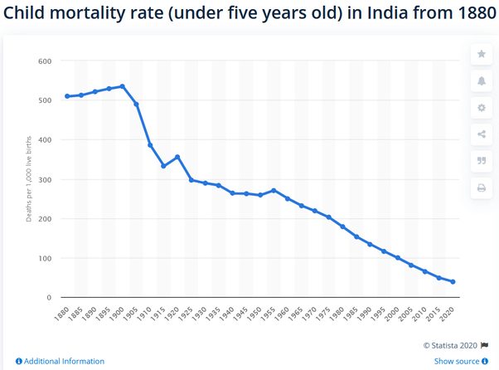

Can someone explain if the demand for essentials like clothes reduced despite population going up, what were poor people wearing in harsh winters ?

[Employment in nineteenth century Indian textiles](https://www.sciencedirect.com/science/article/abs/pii/0014498383900414)

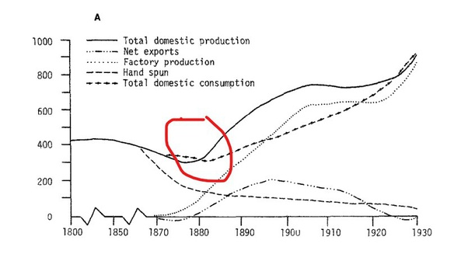

[https://censusindia.gov.in/Census_And_You/old_report/census%201881%20table%20moment%20of%20population.htm](https://censusindia.gov.in/Census_And_You/old_report/census 1881 table moment of population.htm)

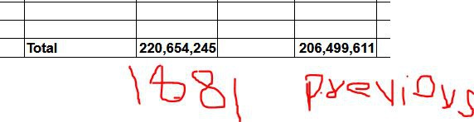

[The reason is that instead of distributing money to reduce effects of the famines of 1870s, the British government chose not to print more currency *{thus not inducing inflation, maintaining good value of Indian currency}*, the economy was doomed. People had to sign indentured servitudes {legal serfdom if you don’t get the term} to avoid economic ruin]





Our currency was almost at the level of dollar when we had to ask the country to voluntarily starve once a week so that food can reach everyone !

[Lal Bahadur Shastri - Wikipedia](https://en.wikipedia.org/wiki/Lal_Bahadur_Shastri)

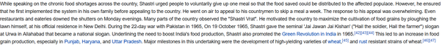

[Value of 1960 Indian Rupees today](https://www.inflationtool.com/indian-rupee/1960-to-present-value)

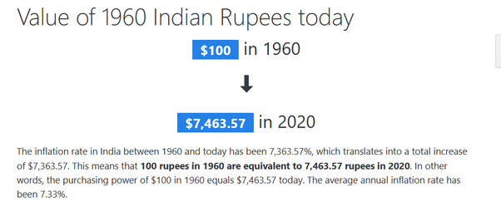

A broad answer is that monetary policy would run to make the people of nation more prosperous on an average. The wealth that is created would be distributed more amongst the people making new money. The old money, however, would want the value to stay fix to continue their hegemony.

***You cannot make blanket statements about inflation, there is “bad inflation” and “good inflation”. As long as your living standard doesn’t go down due to inflation, you cannot really complain.***

### Q. Why do we need to sweat day and night for small salaries in India? What's wrong with the Indian employment system?

Originally answered here : https://qr.ae/pNcPOe

Well, I think things have changed a lot now. Risktakers/Experts can actually now make big bucks, that was not the case in the socialist [Licence Raj - Wikipedia](https://en.wikipedia.org/wiki/Licence_Raj)

days { Degradingly called Hindu Growth Rate by Economists, wonder what Hinduism has got to do with Fabian Socialism we were practicing till 1990}.

The way to making lot of money in Capitalist Neoliberal Economy is Specialization. The way to make money in Libertarian Capitalist Economy is risk-taking. India, as of end 2020, is luckily a mixture of both. Society’s views are pro-capitalist {international solar alliance, agricultural/labor reforms, every administration in India is “Adani-Ambani” in some way} and pro-small business {startup India, Mudra Yojna} at the same time, so you can either become an expert and make money by helping the large capitalists scale or take risks becoming a small capitalist yourself and make money. If one feels they are under-compensated, they are basically averse to both risk-taking and specialization. With a population of over a billion, if you are working in a job with no moat [that is there are too many people to replace you in the real world], economically you would earn less. Economy and businesses are planned and run based on a country’s return on investment and they were mostly built in India assuming low cost of commodity labor given high population. One cannot bank on businesses to finance their foreign trips and “Tata Harrier”s without making efforts oneself. If you increase the cost of commodity labor {by having a white collar minimum wage}, the current economy won’t work at all and there would be need of a different type of economy. I mean guess why white collar jobs are escaping America (and some of them come to India) , their middle class cannot give away the jobs they already hate to their poor class.

[Who Sent American Jobs Away?](https://www.forbes.com/sites/panosmourdoukoutas/2016/05/01/who-sent-american-jobs-away/?sh=4e5a989f62ec)

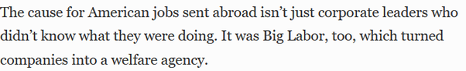

Indian middle class needs to realize that the type of aspirations they now have cannot be fulfilled without risk taking {as in starting new business / doing high risk high return investments} or world class expertise {becoming a top class doctor or engineer, not the most educated but getting the best results}.

As I said earlier, in India possible reasons for not making “good money” can be :

**Bad Luck**

Many people are just unlucky. Have low risk appetite. Maybe parents did not save as much, father was an alcoholic and so on, so cannot really start a business. Parents were maybe not around so had to take up any commodity job to take care of siblings. People are more constrained and much less of individuals than we think.

**Lack of Risk Taking and poor spending habits**

What has not changed is mentality of many Indians, specially many from our middle class which is still living in the socialist bubble of safe long term jobs while adopting capitalist materialistic spending habits {Basically we have inflated our expenses like in America, but still want safe and cosy jobs like Soviet Union}. One must think of what small risks can they take and grow in long turn. Missing Saturday “quality time” with friends is ok when you are trying to learn a new field which you see potential in.

[Muktabh Mayank's answer to What do people who are more than 45 years old do after getting fired from their job due to cost cutting?](https://www.quora.com/What-do-people-who-are-more-than-45-years-old-do-after-getting-fired-from-their-job-due-to-cost-cutting/answer/Muktabh-Mayank)

**Lack of quality white collar employees**

Many of our white collar employees still don’t know their field well. I mean try making graduation process of universities more hard work {maybe by having more practical exams} and see students sulk. Many “experts” in India are just social climbers, can do office politics well. Lack of an intellectual elite has basically convinced many Indians that being “so so” at their job is fine. So so cannot take one places. Cosy sure shot board exams and degress in name of student stress are doing no good to our society. The way to reduce student stress is to reduce stigma around failure and not just make getting a degree easy.

[Muktabh Mayank's answer to Why has engineering education become substandard after the IT boom? Older generation engineers were really makers. Now nearly half of the graduates are unemployable.](https://www.quora.com/Why-has-engineering-education-become-substandard-after-the-IT-boom-Older-generation-engineers-were-really-makers-Now-nearly-half-of-the-graduates-are-unemployable/answer/Muktabh-Mayank)

### Q. How can Indian Railways be improved without privatisation and considering poor people's budget?

Originally answered here : https://qr.ae/pNcqwJ

You don’t need “privatization” necessarily, but you cannot deny that privatization works better than current state run companies for sure.

If we need to grow railways faster than the current rate, we need many things that privatization brings in.

1. Ability to get asymmetric gains {social/economic} for asymmetric efforts/risks. Basically if someone works extremely hard and takes extreme risk to implement something great, they should be rewarded asymmetrically for its success. If there is no incentive to gain, no one would come out of their comfort zone and innovate. If someone tries to do something great as a “state” worker, credit will be taken by their bosses and politicians and they might not even get a raise.
2. Competition. Unless there is no competition, there is no incentive to really care about the customer if there is no fear of customer rejecting one’s business.
3. Answerability : Hardly any government employee gets fired for misdeeds and no one gets fired for working worse than expected. If you know your career is not getting a boost by working hard (point 1) and you wont be fired for working with ease, why would you ever want to change anything ?
4. Accepting change and {small} failures : It’s ok to take small initiatives for change in status quo and fail in many as long as we succeed in a few. Its related to point 1, if there are individuals on whom railways can take small initiatives and they get great rewards if successful, they would come up with many ideas which would transform the system. A more specific way can be : “employees get Rupees 1,000,000 to run a project and become CEO perpetually if they come up with a good one and they loose their job if they couldn’t make the idea work till a certain level”. However, change and small bets are both not easy to digest in a bureaucratic system. So even if a government wants to bring about change, state run organizations like railways would rather take large institutional bets like trusting a large MNC for a project {not the institution itself, Indian Railways are not building India’s HSR or hyperloop} rather than many small indigenous projects. The project would be commissioned only if there is general acceptance for change and given the resistance we are seeing to reforms in India, even such large projects will be rare. Look at the resistance to the high speed rail projects or more recently farmer reforms.

So basically nudge citizens to take ambitious projects as government employees and make sure the ones who are lazy are eliminated. You can clearly see why these points would not be a very popular opinion with many people in bureaucracy. They won’t sell well politically too because deep inside, everyone wants government jobs to be chill and laxed out despite them facing the brunt of slow bureaucracy anyway, in case one day they get lucky with such a job.

You have to understand that railways as a government run industry is not just a welfare for poor people who want to travel {so tickets are low cost}, but also a welfare for middle class who can take easy comfortable jobs. When running a welfare state, the services will be as good as the amount of riches {wealth} in the country. So our railway system is according to our current per capita income. As per capita income rises, it will keep getting better. So you can see things happening too, I have always used Indian Railways and there has been incremental progress from the time I remember [2000 onwards]. If railway is bad according to you now, it was really really bad in say 1999, on all possible parameters.

It will be a collective decision if we want any state run institution to grow at a faster rate than economy and in that case we will have to stop running it as a welfare bus, at least on employee side.

### Q. Why do most of the couples nowadays have no kids or hardly have at least one kid in India? Is the Indian economy really in that bad situation when compared to the rest of the world?

Originally answered here : https://qr.ae/pNJkhZ

The Indian economy was in much much worse shape under the British or in the timeframe of 1985–1991 when Soviet style socialism had made the whole system rotten. Indian reproduction rate was much higher then than it is today when India is actually a much richer country. So I guess that should counter the point of correlation between low reproduction rate with bad economy.

Also I think the 1 kid hypothesis is generally true for Indian middle class or upper comfortable middle class and not middle class and below. I am not able to find very clear stats about it, but in my observation, reproductive rate is much higher than 1 in the less economically advanced communities. Its generally the elites and businessmen and people working in formal economy who have a low birth rate. I will discuss this later, but my assumption in this question is that this premise of birth rate lower than 1 is primarily about middle class people working in formal economy.

In my view, the reason is that the ever growing Indian formal economy runs on meritocracy. If you want to understand meritocracy more , I had written about it in this answer : [Muktabh Mayank's answer to What will happen if India embrace meritocracy?](https://www.quora.com/What-will-happen-if-India-embrace-meritocracy/answer/Muktabh-Mayank)

Meritocracy starts with selecting the best people to run organizations and projects by resorting to competition. “Competition” is actually really good for the economy, individuals and society in general as better people running projects make the system work much more smoothly. You can look at India’s growth and influence which has been increasing since it embraced meritocracy in economy in 1991. [Economic liberalisation in India - Wikipedia](https://en.wikipedia.org/wiki/Economic_liberalisation_in_India)

. India’s post independence top bureaucracy has always been admired because of its meritocratic nature. [Union Public Service Commission - Wikipedia](https://en.wikipedia.org/wiki/Union_Public_Service_Commission)

.

***However, due to the introduction of meritocratic competition in common economy, the work required to make oneself “good enough” and one’s kids “good enough” grows manifold. One has to work hard themself and invest much more on making kids competitive. This means that the sections of society that are in the meritocratic race, will have to concentrate their efforts into themself and a smaller family. If you want to understand who works to make India’s society and economy better, its these people making efforts and sacrifices to push themselves which aggregates as societal growth.*** There are sections of society forced to live on welfare or living in a feudal system, for whom meritocracy is not important and they will continue to stick to more innate behaviors : [Instinct - Wikipedia](https://en.wikipedia.org/wiki/Instinct)

. Reproducing as much as the ecosystem can bear is the innate behavior of life.

There is a comfort and ease in the old feudal systems, the people who do well in such systems can just chill and focus on smaller things in life life enjoying company of a large family and so on. There is a reason why people comfortable in feudal systems resist change into a meritocracy even when they know when they will have an inherent advantage in meritocracy. [Like 2020, Narsimha Rao govt too faced resistance to 1991 economic reforms](https://www.cnbctv18.com/agriculture/like-2020-narsimha-rao-govt-too-faced-resistance-to-1991-economic-reforms-7859651.htm)

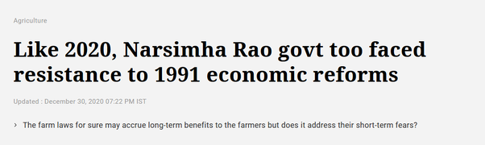

With competition reaching unorganized sectors of economy, you can assume the wealth and well-being to get better there as well, but the reproductive rates would go down even in those segments so that they can focus on . I discussed this point about the disparity in birth rates earlier, the point about that was while the 1991 economic crisis suddenly forced a lot of people into going meritocratic, a lot of them were left behind and were still living in a less competitive, feudal world.

[Impact of reforms](http://indiabefore91.in/impact-reforms)

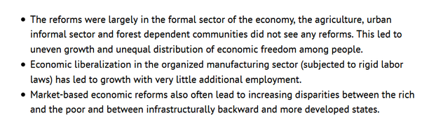

### Q. The future is Asia, why is India not joining RCEP & pivot to US? Do Indians really believe it is their turn to be helped by US? Did US really helped China or exploited China for last few decades?

Originally answered here: https://qr.ae/pNWmUj

There are just too many assumptions in the question.

1. **The future is Asia :** Many people would differ. I think the future is a multipolar world. Different blocks of Asia (China, ASEAN, India, GCC) will be important players going forward. However, to think there will be a common block known as Asia is not a thought I believe. ASEAN and China are very connected right now, but SE Asia will want to develop other strategic interests in future and will be forced to rise up as a separate block from China. Australia’s relationship with China is at a record low and Japan and Taiwan feel threatened by an aggressive China. Unlike Africa or Americas where nation states are arbitrary borders or Europe where they are political concepts day 0 onwards, in Asia nation states roughly correspond to civilizations. Old and perennial, these civilizations will watch out for their own separate interests always and it is hard for them to combine under a common flag
2. **India has pivoted to US :** Yes in terms of defence alliance. China has been continuously showing aggression to India for many years now and India has willingly surrendered some territory to it. [2020 China–India skirmishes - Wikipedia](https://en.wikipedia.org/wiki/2020_China–India_skirmishes)

. With Russia also having close ties with China, India has no option but to diversify its defense partners. India was unwilling and joined Quad ([Quadrilateral Security Dialogue - Wikipedia](https://en.wikipedia.org/wiki/Quadrilateral_Security_Dialogue) ) only after Chinese actions on borders attacking and killing our soldiers. Just two hours back I read a news about China breaching borders of Bhutan, possibly the most peace loving country in the world. This alone proves to me that beingsubmissive and peace loving won't work with China.  
China will keep being aggressive whatever India does because they are just driven by the doctrine of [Five Fingers of Tibet - Wikipedia](https://en.wikipedia.org/wiki/Five_Fingers_of_Tibet)

1. . If India is submissive, that would be even more dangerous for the country’s integrity and the region’s stability. Basically in defence, India is out of options but to support any block which guards its strategic interests against China. However, India continues its friendly relationship with countries in China’s friendlist like Russia and Israel and SCO countries and ASEAN.

New satellite imagery published by [@ndtv](https://twitter.com/ndtv?ref_src=twsrc^tfw), conclusively proves that a new village constructed by China and revealed in Chinese state media is indeed located within over 2 kilometres into Bhutan, according to their official maps and claims (27.307, 89.007).<https://t.co/QVgFeuGzVS> [pic.twitter.com/eaR7lTxgkG](https://t.co/eaR7lTxgkG)

— Nathan Ruser (@Nrg8000) [November 22, 2020](https://twitter.com/Nrg8000/status/1330463914576920577?ref_src=twsrc^tfw)

1. **India has pivoted to US (continued) :** But that doesn’t mean India is in a US trade block. Possibly after US and China, India is one of the only countries which has a large enough internal market, workforce and self-sufficiency to not participate in international division of labors that are crafted our by Free Trade Agreements. We are looking at our building our own profitable trade relations which preserve our existing supply chains and in parallel provide us better opportunities. RCEP has many provisions that will force many people into uncertainty and risk of poverty without significant upsides. When we get an agreement which is a good tradeoff, maybe India still joins it.
2. **Multilateral FTAs like RCEP are the best** : No. Almost everyone agrees that its just too complex to negotiate a multilateral FTA which is a win-win. Better (and harder and slower) way is to negotiate multiple bilateral agreements. These are relatively less risky and lossy. We must probably do that.
3. **Indians believe we will be helped by US:** Most Indians don’t trust US to stand for us. At best they like US much more than they like China (and possibly less than they like Israel or Russia). Indians trust in their ability as a civilization to be sturdy and united. History has proven that being a colony for over 1000 years has not destroyed us and we can manage hardships.
4. **Did US help China or exploit it ?** : US helped China after Nixon till maybe Clinton somewhat strategically like it was helping India during Trump regime (we don't know what change in US administration entails yet). But it was doing so not because of any goodness or nobility. US saw China as a counterweight to Soviet Union then as it sees India as a counterweight to China now. Let’s just agree that all countries are trying to fulfil their own self interests.

TL,DR : Signing RCEP right now is not pragmatic for India. We should negotiate and if we get a good deal, maybe we can sign it. Else we should take path of signing multiple bilateral FTAs. Let’s put our foreign service to work.

### Q. Is India going to collapse?

Originally answered here: <https://qr.ae/pNJvtU>

What does collapse even mean ? Are you thinking about whether India will cease to exist as a nation state or civilizational state or liberal democracy or socialist country or capitalist country or what ? Its just such a broad question. The alteration of a “Status Quo” one likes is what one would call “collapse”.

Will India go through Phase Transitions ? Yes.

Will India collapse ? Not likely. The older a system is, the more flexible it is to changes and less likely it is to collapse. A newer system can die out pretty soon, the older a system is, the more capacity it has to adapt and survive. India is really old, possibly the oldest living civilization !

Many Indians (specially elites and middle class ones) are people averse to big changes and thus they assume any change that comes along will lead to “collapse”. After all, they are ones who have been pampered to seek rent by the ruling classes in a way that they continue thinking that status quo is “necessary”. Since middle class and elites are more vocal, you see their versions of “collapse” floating around on social media.

Collapse is just one out of the many possible outcomes of an phase transition in a complex system.

So for example, India’s communists were worried about subsidies for India’s poor becoming worse off at the time of economic liberalization in 1991, when India was coming out of its socialist past : [Economic Crisis Forcing Once Self-Reliant India to Seek Aid (Published 1991)](https://www.nytimes.com/1991/06/29/world/economic-crisis-forcing-once-self-reliant-india-to-seek-aid.html)

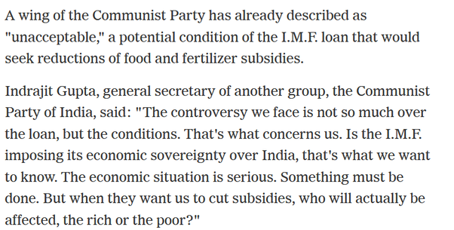

We are spending even more on food subsidies after we became economically more prosperous :

[Govt. subsidy spend on the rise again](https://www.thehindu.com/business/govt-subsidy-spend-on-the-rise-again/article26187273.ece)

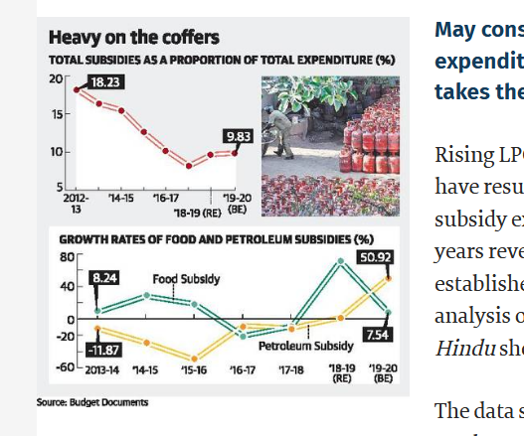

The fear of collapse is the fear of the loss of status quo. “Status Quo” benefits some people, they become powerful and will try to oppose any changes as they see their personal power decreasing as “collapse” of civilization. IMO, the opposition to recent agricultural reforms is precisely that : [Muktabh Mayank's answer to Why are farmers in Haryana and Punjab protesting?](https://www.quora.com/Why-are-farmers-in-Haryana-and-Punjab-protesting/answer/Muktabh-Mayank?ch=10&share=a170d6b8&srid=qie) .

India has immense economic potential, but the current economic/bureaucratic system is not the best way to realize this potential, so it would be a possibility that there are phase transitions in our economic system. Basically change in fundamentals of economy which would not support the the current ways in which the economy works. The people know that the status quo needs to change, that is why the powerful democratic mandates they has been giving to our leaders. PM Modi, KCR, Kejriwal win by massive majorities to change the status quo, compare it to just 10 20 years back when we had “revolving door” governments. Of course the people who are at an advantage now will resist and create a hue and cry over changes, calling them collapse.

Phase Transitions are risk, so is not going through changes ! We are lucky that Indian people are willing to accept change. This actually makes sure India will not collapse due to social entropy. More about social entropy here : [Muktabh Mayank's answer to Will the 5G internet make this world a chaotic place?](https://www.quora.com/Will-the-5G-internet-make-this-world-a-chaotic-place/answer/Muktabh-Mayank)

### Q. If India bans all private cryptocurrencies and introduces a single official digital currency issued by the RBI, how will it affect the economy of India?

Originally answered here: <https://qr.ae/pNzj8e>

There is some misplaced sense of bureaucratic logic that is driving this initiative. RBI tried to ban other cryptocurrencies while launching its own crypto and when that was struck down this has been sent to the parliament. I hope our government and members of parliament understand that CBDCs [Central Bank Digital Cryptocurrencies] and decentralized cryptocurrencies have two very different applications and banning the later is not required to get a market for the former. The competitors for CBDCs are international centralized coins like Libra {Now called [The Diem Association](https://www.diem.com/en-us/)

}, other upcoming CBDCs like China’s and EU’s and not Bitcoin/Ethereum and its brothers. We are fighting the wrong monster here.

**CBDCs usecases :**

The top benefits of a CBDC are :

1. Quicker disbursement of government financial aid/UBI. While right now RBI prints currencies, sends to government/banks and banks then disburse the money, A CBDC can be minted and disbursed almost immediately after decision is made. A few years back, when this disbursal was done through cash, there was a lot of corruption and even more delay which fintech has already solved, now CBDC when combined with fintech would make the process instantaneous .
2. Tracking flow of money is another cool thing about CBDCs. While for most citizens the CBDC ledger is anonymous, the government accounts will be public and people can see where there tax money have been spent down to one rupee. This ensures certain types of corrupt practices will be much easier to detect and highlight. In a way good step to check public sector corruption.
3. Indians are already accustomed to digital currency [You have amazon wallet cash, paytm wallet cash] and so on. While right now, this cash is guaranteed by the companies, CBDC as a digital cash will be guaranteed by the government. These are two very different type of guarantees. Sudden nationalization of AliPay for example makes a lot of AliPay guaranteed digital money of SouthEast Asian and African businesses using AliPay, Chinese government guaranteed money. Not sure how comfortable people would be wit that, but private companies are under umbrella of the countries they have their effective center of control in.

**This is in total contrast with how decentralized cryptocurrencies [like Bitcoin] are being used in today’s day and age:**

A. Decentralized Cryptocurrencies are emerging as a hedge against poor monetary practices of a government. When a government is printing money like newspaper, people need ways to preserve their wealth and not need to depend upon other governments for their currencies and CBDCs. That is what main usage of Bitcoin is in current day. Bitcoin/Ethereum is not really useful for transactions because of the slow nature of transactions.

B. The other prominent usage of decentralized cryptocurrency is as a vehicle currency, that is way to send money abroad without all the charges involved today. This is possibly the use that government officers might be worried about and rightly so due to security concerns. There should be strict ways to regulate the improper money transfers but in my view banning decentralized cryptocurrencies over this is a bit over the top.

One more concern over decentralized cryptocurrencies is that people can be conned and can lose their savings over bad explanations of the new concept of currency in software.

All in all, I see CBDCs and Decentralized cryptocurrencies operating in parallel without disrupting each other.

### Q. Will the privatization of banks solve or complicate the problem?

https://qr.ae/pGXEUJ

“Privatization” is a very broad phenomenon and if we discuss it as opposite to “Nationalization” that happened in 1969, we are just thinking quite badly. Privatization is not going to be the reverse of what happened in 1969, it cannot be. You cannot reverse 50 years of change !

Unfortunately, that is the emotional “flight or fright response” that would come to the stakeholders and they would go in war mode to protect status quo they are accustomed to. On the other end of the spectrum are “free market” zealots who just want to offload everything of government’s hands without understanding the long term implications.

We need to understand that there are pragmatic decisions that can help everyone in long run. Of course, there are people who have built moats and arbitrage on current status quo and they would be worried as their advantages are ripe for disruption. For others, a lot of the apprehension is just fear of change, the people getting disrupted will make sure they fan this fear to get a political victim group.

We need to ponder about many points :

1. What is the current role of different public sector banks ? What needs to be in public sector and what doesn’t ?
2. Are all public sector banks doing like they are expected to do ? Shouldn’t their working structure change if they don't ?
3. Whose control are the public sector banks under after they were so called “Nationalized” ?
4. Whose control the banks would pass to if they are “Privatized” ? Are they under more scrutiny now or will they be if their stocks were traded like Reliance’s and HDFC banks are ? Or will be the banks be sold to strategic buyers for high valuations ? Unlike what many people think, privatization is not always things becoming out of control of country’s citizens.
5. Why are the public servants so afraid of shifting to private sector ?

Some pondering points based on above question :

* I don’t think the government is going to just loose control of all banks. That would just not work with the institution of government itself. The exercise is to get rid of the fat, the banks which perform badly and have no hope of redemption.
* The welfare schemes [access to free banking and money transfers] need to continue to keep the society content and private banks won’t be interested. So just to keep the country running smoothly, there will be need of institutions secured by taxpayer money. I guess these 2 points would convince you that we are not going to see a reversal of 1969, its just going to be restructuring according to new times.
* But here is a question : if welfare banking is taken care of by some efficient government run banking institutions [easy access to banks in remote areas, zero balance accounts, cash transfers/UBI], does the government need to run most/all retail banking in the country ? Specially when government has put regulations making sure even the privately run banks have to participate in many welfare banking schemes ? Do you really think that all public sector banks are competing on basis of their services with other banks ? There are few very well run public sectors banks, but majority of these banks are just existing because taxpayer is bound to let them live. The ones working well should take up welfare banking and the ones who are just surviving should face market competition to become better. Remember more competition is always better for consumers. Taxpayer cannot fund loss making assets forever, which are not just a direct sink of taxpayer money but might also distort the market by producing wrong incentives by taxpayer money.
* Another very important emotion that somehow is pumped into people is that “Nationalized” banks are somehow under their control and all “Privatized” banks are controlled by some outsider entity. Its such a bad generalization and tells about financial literacy of the country. They need to understand that most “Privatized” banks are “Public” companies and are in much better scrutiny of common people than bureaucrats running public sector banks without any fear of consequences and any incentive of making it big. Being a publically traded company in India ensures that banks are facing market competition, being trusted by people and are still under Indian laws. Most Indians need to realize that these public companies [LIC is to one become soon] are what pays them the high interests on fixed deposits and PPFs and banks anyway indirectly invest into these. The equating of Indian Public companies [HDFC, Reliance, Infosys, TCS] with East India company has damaged an average Indian’s financial literacy a lot, we need to stop that. As long as there is a democratic government making laws on finance and trading to make sure people’s concerns are taken care of, public companies are efficient public sector companies only. This doesn’t mean that there would be no NPAs and no scams in private banks, but we will definitely address them faster and management would be much more mindful of such things happening.
* There would be some strategic sales for bank privatization too. This is possibly what people fear and imagine all privatization looks like. Selling to business houses. Its a battle of top 0.1% and top 1% and commoners like us just spectators here. All we can understand is as long as government can force the buyers to be controlled and scrutinized by Indian public, we are fine. One way is to force to keep existing people as employees, making sure the buyers cannot use the income from such banks to diversify outside India and so on. If the new elites interests are tied to Indian people, we are going to be fine. The way to use capitalism to our benefit is “*interest alignment”.* Always look at the terms of sale and not the cumulative amount the bank sales made. [Emotional people would often think a sale at a higher amount is always better].https://www.sapling.com/5991158/interest-alignment
* Indians need to stop thinking about economics with simple perspectives like “privatization is bad”, “nationalization is bad”, “all foreign money is bad” and learn to use capitalism to our benefit. Pure ideology is almost always impratical. Interest alignment, Matthew’s Principle and risk evaluation is the way. Also we need to stop offloading our economics thinking to “experts” without understanding their core beliefs and affiliations.
* One thing is about the employees of public sector banks. We have to understand why they don’t want to work in a private institution. Is it because of “lack of security in private institution” or “lack of responsibility for actions”. This is a line that the elected government is made to draw. They cannot let people be exploited but cannot let people take undue advantage of their position as well.

***Some more thoughts of mine you might want to read in this context :***

Why some privatization without losing control is important :

### Q. If the Indian government privatizes all jobs and advanced technology takes over all paper work and manual labour, how are the middle class and poor going to survive?

https://qr.ae/pNdRa8

There are some basic assumptions in the question which are all wrong :

1. Government can privatize all jobs.
2. Government running all economic sectors and all jobs as government jobs is feasible and scalable.
3. Manual Labor and paperwork are the jobs which middle class and poor class can do.
4. Automation makes the number of jobs zero.
5. Survival needs a job.

People are driven by fear. It is a very powerful emotion. People would look at today’s circumstances for negatives and will guess a few negatives of new reforms and combine both to imagine a horrible future. This question is addressing a fear the possibility of which coming true is very low. Remember half of the world doesn’t sit static while the other half changes, society and economics is a thriving self-repairing ecosystem. Things work out in favour of those who take risks, not those who avoid them due to fear. One cannot help the feeling of fear though, the amount of negativity in main stream media and social media keeps making people imagine unrealistically bad scenarios which are not possible. I mean look at the way they tried to sensationalize India’s possible COVID scenario :

Remembering Dr. Ramanan Lakshminarayanan who had extrapolated a statistical model of 300 million Covid cases and 3 Million deaths in India by August 2020. Goes to show how much GAS is being telecast on Indian News TV with 0 accountability.

— Trendulkar (@Trendulkar) [March 1, 2021](https://twitter.com/Trendulkar/status/1366437556015927300?ref_src=twsrc^tfw)

It turns out things were waaaay better than this in August. Most negative things you are made afraid of before they start rolling out a new change can be checked much before they become true, so there is no need to nip progress in the bud due to a 1% negative possibility. “Let a phenomenon become a problem before you start opposing it.”

Let’s talk about your assumptions one by one :

**Government can privatize all jobs :**

They cannot. There are some people that the government will need to employ on their roll. These jobs are elected officials, bureaucrats to negotiate on part of people, industries and scientific institutes which cannot really run without government’s backing [like say Nuclear Industry, Agriculture and Medical research, Some amount of healthcare or Defense Research]. But do you really want government hiring people for running airports or running malls or running zoos or running schools ? I discuss that in the next answer.

**Government running all economic sectors and all jobs as government jobs is feasible and scalable :**

Don’t you think most government jobs in service sectors are more of a way to please people than actually address demands :

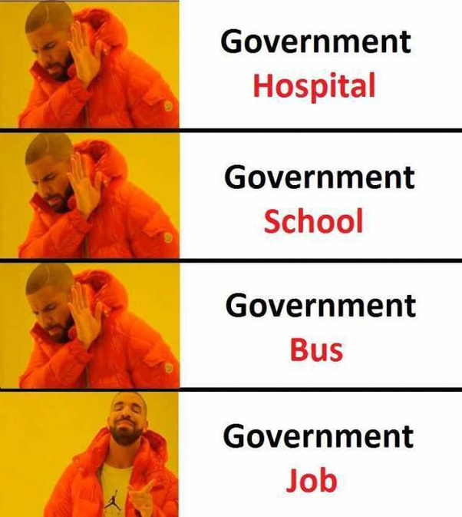

The comfort and stability and freedom to do nothing in public sector jobs [for which most Indians are attracted to them] are essentially the reasons why the services public sector companies provide is poorer. You don’t need to worry about demand if taxpayer is backing you.

Government entering into services and mass employment sectors like real estate, banking etc is generally a recipe for disaster. Most Indian public banks were doing really bad until massive restructuring in their management has been started recently. The reason is simple, government jobs can seldom provide the incentives private sector employments can provide. One way is to basically simulate private sector like incentives/accountability in public sector jobs :

https://www.quora.com/How-can-Indian-Railways-be-improved-without-privatisation-and-considering-poor-peoples-budget/answer/Muktabh-Mayank

However, pulling off such a thing is hard in democracy, where effectively jobs are a way to setup comfortable cushy salaries for supporters. That is why privatization is needed. If public can accept such changes in structure of government jobs, we can indeed live with lots of public service jobs. Try a referendum among government servants and aspirants with the changes I suggest in linked above answer and see !

China has done “exposing public sector jobs to market forces” like I suggest in linked answer above and has succeeded. Maybe because they are not a democracy. So has Singapore, by being much less democratic than you see. Most examples of paradigm shifts in democracies have come from risks being taken in private sector.

https://www.quora.com/Is-it-the-business-of-government-to-run-business/answer/Muktabh-Mayank

It might sound like I am saying that private business ownerships should be no strings attached and unregulated. That is not what I mean. Private sector companies should be allowed to take profit only if they are not making country less competitive {just like comfort of no market pressure in government jobs makes public sector enterprises less competitive, similarly companies making profit by making the country venerable to risks make the economy weak in the long run too}.

https://www.quora.com/Why-isnt-Trickle-Down-economics-working/answer/Muktabh-Mayank

The answer is to have private companies which stay competitive and the effective center of control is with the people. Fear of leaving comfort zone makes humans demand the opposite : safe public sector jobs and private companies that can make profits at any cost.

**Manual Labor and paperwork are the jobs which middle class and poor class can do.**

Why so ? There are many many jobs that don’t exist in our country as much as it should. Why should lower middle class people be just clerks and poor people laborers at construction and farms ? Cannot more opportunities open up for them ? Percentage of poor people could be reduced in population just like China or US did in 20th and 19th century respectively. Middle class would become the majority eventually if economy grows fast. People could be technicians at automated factories, looking after data center farms, healthcare professionals [which India has much less than required due to gatekeeping] or do more dignified work like running construction and farm machinery rather than doing back breaking work.

How simple to think that the efficiency privatization introduces into the economy doesn’t lead into any growth and evolution of economy. Jobs will get partially automated [not fully], reducing the number of jobs per institution, but total number of institutions will rise as well maybe even creating an excess of jobs. Also, a richer economy will create more and more sectors. People won’t be forced to work the same jobs as today when economy grows, at least not in same percentage of population. Automation has been around for a very long time and number of jobs has been growing.

https://www.quora.com/As-a-result-of-the-Fourth-Industrial-Revolution-will-any-job-be-lost/answer/Muktabh-Mayank

**Automation makes the number of jobs zero**

Due to some reason [Hollywood movies or MSM descriptions or whatever], people believe in the false story that one day they will wake up and go their workspace where a robot would have replaced than and they would be given a pink slip. That makes a terrific story and can be made into a hit movie, but its not really true. Automation will not spread like CoronaVirus. It takes investment and deployment and time. Enough time to make one aware and reeducate oneself for a new job. All we need is people not living under rocks.

https://www.quora.com/Should-doctors-be-replaced-by-artificial-intelligence-and-surgical-robots/answer/Muktabh-Mayank

The world can course correct. If something goes wrong with automation, there is enough time to think and make a strategy around how to address it. Even for fast spreading things like CoronaVirus, the world went into lockdown and slowly figured out ways to respond. Automation comes much more slowly and we have compensated for it many times. Just that in past, it took a few generations and now its faster within timeframe of one generation. Most of the people joining the workforce in recent years should be aware that they would need to retrain for at least one new jobs in their lifetime. But that doesn’t mean there would be no jobs, just different ones.

**Survival needs a job**

One can ask what if the rate of progress becomes so fast that one would not be able to reeducate for new work ? First of all that is a few centuries away, but if this type of a situation arises, it is a good scenario. I think we would have solved problems around poverty and cancer and death by the time we achieve this. The entire thought and philosophy of humanity would be different at this juncture. [We might not even reach there if we choke our ecosystem with CO2 or burn our food and freshwater by global warming]. Such scenario is so far fetched and away in future that we cannot imagine it and thus can portray it in whatever way we want :







We don’t have the ability to imagine economics exactly at such intergalactic scales. We can just guess. In my opinion, jobs won’t even be an issue by then or maybe we will have jobs that we cannot imagine : warmhole destroyer, star miners or whatever. I prefer not to worry about such scenarios right now.

### Q. Should the purchasing limit be imposed in India based on requirements to control inflation?

https://qr.ae/pGvtHv

No !! Inflation in India is at a very decent level. You drive it below the current trend of 5–6 % and you are basically stopping infrastructure development and welfare activities. Esp. during COVID times, its very important to have some UBI during lockdowns.

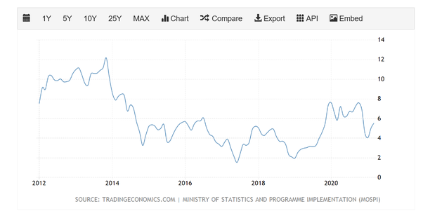

Ref: https://tradingeconomics.com/india/inflation-cpi

You need some infrastructure projects and welfare programs in a rapidly growing economy. They will require government to generate some cash as debt {Most inflation in a growing economy comes from here}. In a growing economy, while some people would rapidly grow [because they are the right place at right time], others might slack off or be left behind and need to be kept in the race by supporting them a bit.

Having no [<2–3% i India] inflation in a growing economy is somewhat like having high inflation[8-10%+ in India]. It just creates unnecessary pressure where none needs to exist.

### Q. Should Uttar Pradesh be divided into four parts for development?

https://qr.ae/pNQxeO

I used to buy the “small states for better development” hypothesis, but overtime I have developed a more neutral outlook towards it. Smaller states have more homogeneity (and thus they are more efficient), but they have their limits and cannot do better after a certain level. Singapore developed much faster than China and is a great and efficient country, but once China took Singapore's tricks and scaled them, its a behemoth. There is effectively no limit to what China can do, while Singapore can at best be a rich city.

**UP during the 1990s and 2000s :**

I think the reason for the “state division” hypothesis [in days of its popularity] was, its very hard to make a lot of people agree to decisions, so lets make the round table smaller and be efficient. That has been the case with UP in past, its huge and basically so chaotic that we have been seeing suboptimal progress. There was a conspicuous political movement in east UP [I know much more about east UP than the west] to achieve statehood as Purvanchal and recognition of our language Bhojpuri in Indian constitution. Bhojpuri of east UP is as far from Khadi Boli [official Hindi] as say Marwari is in Rajasthan or Haryanvi is. Everyone in east UP speaks official Hindi though.

[Parties fighting for smaller state band together](https://www.rediff.com/news/2008/aug/28hyd.htm)

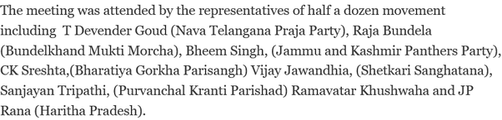

The 1990s-2000s were horrible. While the rest of the country was rallying in post 1991 economic liberalization boom : [Economic liberalisation in India - Wikipedia](https://en.wikipedia.org/wiki/Economic_liberalisation_in_India)

, parts of UP [I know much better about east UP] were still stuck in the 1980s. No infrastructure investment, crime and lower purchasing power with respect to rest of the country was the norm. Government servants {for nationalized industries in east UP which were the only source of employment} were being paid with 4th pay commission [that’s socialist economy numbers proposed in 1980s during the high inflation years of late 2000s] .

[4th Pay Commission](http://www.cgspublicationindia.com/4th_Pay_Commission.aspx)

[India Inflation Rate in 2008](https://www.statbureau.org/en/india/inflation/2008)

[India Inflation Rate in 2009](https://www.statbureau.org/en/india/inflation/2009)

There were days with power for 4–5 hours in tier 3 cities {so worse in towns and villages} . I have clear memories of solving Maths problems from Hall and Knight after I competed high school in earthen lamp like this in 2006 on a summer evening when temperature was over 40 :



East UP during the 2000s felt as if the nation had left it behind :

[The India Bush didn't see / The nation's liberated economy -- portrayed by globalization forces as an antidote to poverty -- has done little for nearly 300 million poor people, the most of any country](https://www.sfgate.com/opinion/article/The-India-Bush-didn-t-see-The-nation-s-2502576.php)

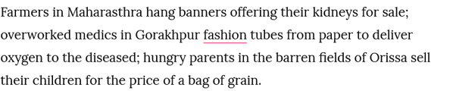

The Oxygen delivery mentioned in the above 2008 article is for the Japanese Encephalitis endemic that used to kill 100s and sometime 1000s of children every year. The only time the national media found it interesting was when children died due to a scandal in 2017, actually making a spicy headline : [Japanese Encephalitis in Gorakhpur: A deadly disease explained](https://www.thehindu.com/sci-tech/health/japanese-encephalitis-a-deadly-disease-explained/article19486806.ece)



The only infrastructure project my city had during entirety of my childhood [a flyover connecting the two parts of my town] was started when I was a kid in 1995 and was competed after I finished my high school in 2004. A supposedly upper middle class person [father an Engineer in public sector] from east UP had to apply for merit cum needs scholarship in an all India university and the college staff refused to believe the salary numbers in the first application. We were massively capital starved and thus there were no local jobs, no industries and the region was filled with dog-eat-dog crime. All the stereotypes of UP you see in the media “Mirzapur”, “Rangbaaz” were actual stories from this era.





We had the entire “bhaiya” culture from east UP of people migrating as cheap laborers elsewhere, specially in metro cities and Punjab. This damaged poor people’s incomes in those parts :

[Punjab: Land struggle in the time of pandemic](https://frontline.thehindu.com/the-nation/punjab-land-struggle-in-the-time-of-pandemic/article32024163.ece)

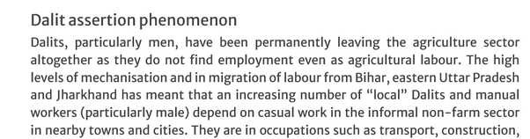

and there was a wave of anti-immigrant politics against people from east UP:

[Raj Thackeray - Wikipedia](https://en.wikipedia.org/wiki/Raj_Thackeray)

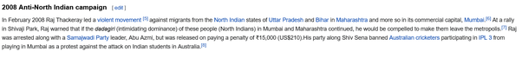

Needless to say, people in east UP were pissed and thought maybe a separate state would get them some boost. That has however changed in 2010s though.

**UP in the 2010s and early 2020s**

Development of remote parts of UP suddenly became electorally much more important in 2010s due to its political strength. In just last 5–6 years, my hometown which took years to build 1 flyover has transformed its infrastructure.

Varanasi has an inland port :

[Varanasi Multi-Modal Terminal - Wikipedia](https://en.wikipedia.org/wiki/Varanasi_Multi-Modal_Terminal)

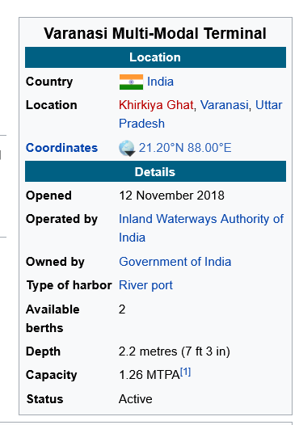

There is an AIIMS and Virology center for Encephalitis problem:

[Regional Medical Research Center Gorakhpur (RMRC Gorakhpur)](https://rmrcgkp.icmr.org.in/)



[All India Institute of Medical Sciences, Gorakhpur - Wikipedia](https://en.wikipedia.org/wiki/All_India_Institute_of_Medical_Sciences,_Gorakhpur)



And Japanese Encephalitis endemic is almost dead :

[‘Big shout out to Uttar Pradesh government’, UNICEF lauds CM Adityanath’s DASTAK campaign against Japanese Encephalitis](https://www.financialexpress.com/india-news/big-shout-out-to-uttar-pradesh-government-unicef-lauds-cm-adityanaths-dastak-campaign-against-japanese-encephalitis/1147716/)

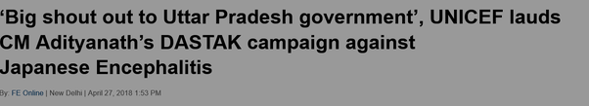

Many new industries have become operational :

[53 sugar mills still operating in Uttar Pradesh; state heading towards record sugar production - ChiniMandi](https://www.chinimandi.com/53-sugar-mills-still-operating-in-uttar-pradesh-state-heading-towards-record-sugar-production/)

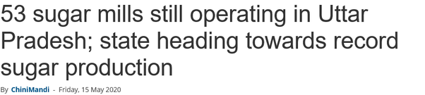

Sugar industry was UP’s largest employer pre-independence , but the industry was almost dead a decade back :

[Sugar bowl loses its sweetness | India News - Times of India](https://timesofindia.indiatimes.com/india/sugar-bowl-loses-its-sweetness/articleshow/11816162.cms)



[India to invest Rs 50,000 crore to revive four mothballed fertilizer plants](https://economictimes.indiatimes.com/industry/indl-goods/svs/chem-/-fertilisers/india-to-invest-rs-50000-crore-to-revive-four-mothballed-fertilizer-plants/articleshow/58403537.cms?from=mdr)

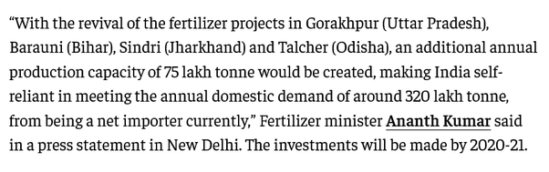

There are new airports and expressways :

[Ayodhya Is All Set To Get An International Airport Soon, Centre Allocates Rs 1,000 Cr For It](https://www.msn.com/en-in/news/other/ayodhya-is-all-set-to-get-an-international-airport-soon-centre-allocates-rs-1000-cr-for-it/ar-BB1e2PeD)

[Kushinagar gets DGCA clearance, becomes third international airport in UP](https://www.msn.com/en-in/news/other/kushinagar-gets-dgca-clearance-becomes-third-international-airport-in-up/ar-BB1dVZIR)





[Purvanchal Expressway - Wikipedia](https://en.wikipedia.org/wiki/Purvanchal_Expressway)

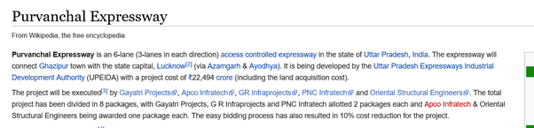

[Bundelkhand Expressway - Wikipedia](https://en.wikipedia.org/wiki/Bundelkhand_Expressway)

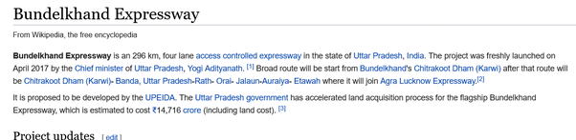

I was only talking of relatively poorer parts of UP above. West UP, which was already more prosperous than east, is getting infrastructure projects which are possibly best in the country :

[Delhi-Meerut Expressway: PM Modi inaugurates India’s first 14-lane highway; 7 facts that make it stand out](https://www.financialexpress.com/infrastructure/roadways/delhi-meerut-expressway-pm-modi-inauguration-highway-facts-images-map-highlights/1182895/)

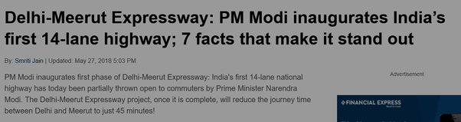

[Delhi–Meerut Regional Rapid Transit System - Wikipedia](https://en.wikipedia.org/wiki/Delhi–Meerut_Regional_Rapid_Transit_System)

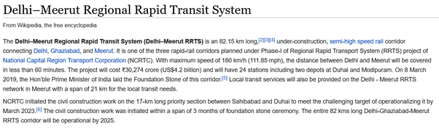

It seems that western UP will become the employment destination rather than going to metro or gulf countries :

[UP Film City to come up in 1,000-acres land along Yamuna Expressway](https://www.newindianexpress.com/nation/2020/sep/22/up-film-city-to-come-up-in-1000-acres-land-along-yamuna-expressway-2200472.html)

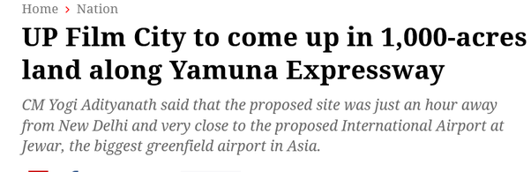

[Samsung Inaugurates World’s Largest Mobile Factory in India; Honourable Prime Minister Shri Narendra Modi Flags-off ‘Make for the World’](https://news.samsung.com/in/samsung-inaugurates-worlds-largest-mobile-factory-in-india)

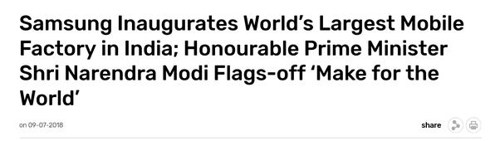

All the latest Samsung phones purchased in our family [including my M series], has been “Made in Noida”. There are also many new huge investments announced in west UP :

[Adani group to invest Rs 2,500 crore in setting up a data centre, says Noida authority](https://economictimes.indiatimes.com/industry/services/property-/-cstruction/adani-group-to-invest-rs-2500-crore-in-setting-up-a-data-centre-says-noida-authority/articleshow/81185744.cms)

[Reliance Jio planning $950 million data center campus in Uttar Pradesh](https://www.datacenterdynamics.com/en/news/reliance-jio-planning-950-million-data-center-campus-uttar-pradesh/)





[IKEA to invest Rs 5,500 crore in Noida, signs MoU with UP govt](https://www.timesnownews.com/business-economy/companies/article/ikea-to-invest-rs-5500-crore-in-noida-signs-mou-with-up-govt/722373)



[German Shoe Brand Von Wellx Moves Out Of China, Begins Operations In Agra](https://www.ndtv.com/india-news/german-shoe-company-shifts-manufacturing-to-agra-from-china-amid-covid-2321742)

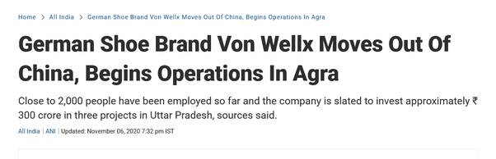

[Uttar Pradesh a priority state for Australian investment: Envoy](https://www.msn.com/en-in/news/other/uttar-pradesh-a-priority-state-for-australian-investment-envoy/ar-BB1e1LQV)



If you are observing, these were not the things UP was known for in the past.

**UP has better bargaining power and larger market when it stays united at cost of efficiency like in smaller states, but more centralized power can counter that**

I guess at least perceptually, the state is doing much better and that gives a glimmer of hope that we maybe can be the Texas/California [or a more relevant example should be Ontario] in India.

In my view, UP has received massive benefits due to insane political power it has wielded recently by voting full majority governments at center and state level. 2014, 2019 general elections and 2007, 2012 and 2017 elections have all been massive landslides giving governments massive decision making powers. Basically UP has experimented with given absolute powers to governments because people were sick of all the chaos caused by fractured mandates and interest-group politics. And that seems to be working well for the state. I don’t think people in UP would want to change that.

Uttarakhand is a state with very good per capita income, but can it be as successful / influential if UP has a similar per capita income in the future ? I don’t think so. Its quite a recognized phenomenon, its even mentioned in the bible : [Matthew effect - Wikipedia](https://en.wikipedia.org/wiki/Matthew_effect)

. What UP needed was some centralization and push from absolute chaos, now that has been achieved, in my opinion, dividing the state is redundant.

Also, there are stereotypes about UP in many answers to this question and comments among them like east UP and Bundelkhand are some brutes who cannot manage themselves and UP is cultureless hellhole that needs a culture reset. Let me remind them that other areas that had been colonized by foreigners [Turks, Afghans, Iranians, British] for an equivalent period of time in India are now Pakistan and Bangladesh, basically not even a part of India. UP has something super solid about it, we got poor under foreign occupation as we funded their armies and conquests and filled their coffers but psychologically we are still following the heroes who lived and roamed here millenia ago and the world follows them too.







Even after independence, our industrial base was choked due to the politics of getting divided into factions :

*Pre independence :*

[Cotton Textile Industry in India : Production, Growth and Problems](https://www.yourarticlelibrary.com/industries/cotton-textile-industry-in-india-production-growth-and-problems/19704)

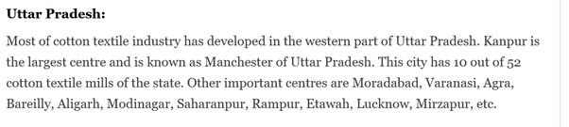

*Post Independence:*

[How the Once Flourishing Kanpur Textile Mills Decayed](https://thewire.in/labour/faulty-govt-policies-corruption-and-exploitation-of-labour-how-the-once-flourishing-kanpur-textile-mills-decayed)

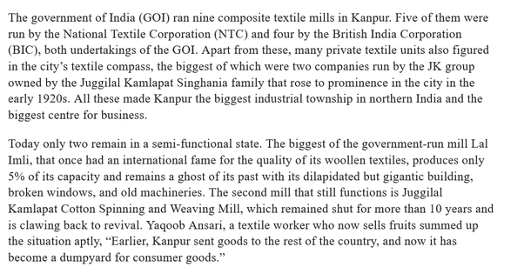

I hope people of UP have learnt their lessons :

[Muktabh Mayank's answer to Is a middle class person really affected by whoever that comes in power in India or whoever comes? Is it still the same thing just with a different name tag?](https://www.quora.com/Is-a-middle-class-person-really-affected-by-whoever-that-comes-in-power-in-India-or-whoever-comes-Is-it-still-the-same-thing-just-with-a-different-name-tag/answer/Muktabh-Mayank)

We have had many poor generations and lost historical documents, but there is no question about the hindi heartland [UP and Bihar] is what Greece and Rome are for the European civilization. Pataliputra and Mathura were seats of powers that Greeks and Romans respected and traded with once. [Gangaridai - Wikipedia](https://en.wikipedia.org/wiki/Gangaridai)

[Muktabh Mayank's answer to Is it true the name "India" didn't exist before 1857, it was given by the British to replace the previously used word "Subcontinent" or Bar e Sagheer?](https://www.quora.com/Is-it-true-the-name-India-didnt-exist-before-1857-it-was-given-by-the-British-to-replace-the-previously-used-word-Subcontinent-or-Bar-e-Sagheer/answer/Muktabh-Mayank)

UP is truly, a sleeping giant. Once it rises again, it could be the Texas/California/Ontario of India. Harit Pradesh or Purvanchal would become just another Goa or Telangana. Both are fine circumstances for people in UP as long as India is developed, independent and prosperous country, but if you ask me, I prefer former to the latter. Other people of UP would think so to if they reason the way I do.

### Q. How did Y2K prove to be a boon for the Indian economy?

https://qr.ae/pGvtoC

Indian IT firms suddenly got a platform, exposure and trust to attract most international institutions. Now mind you Indian IT firms were around for sometime, but there was a hesitation in outsourcing whole or part of IT tasks.

But with the Y2K fear suddenly being realized {Many companies realized it as late as 1998 that their programs might be denoting years as YY ans not YYYY and thus might fail on 1/1/2000}, too much work came up to be done before year 2000 for not outsourcing.

https://en.wikipedia.org/wiki/Year_2000_problem

The work was comparatively less in writing subparts of programs with YYYY format, but as usual like in Computer Science there were too many abstractions and one could never know what errors new changes would introduce. In areas like defense, banks, finance, healthcare, insurance, telephones etc such errors would be a big deal.



So US companies had to look outside, were forced to look outside and that is where Indian IT firms got headways into departments and institutions they had never been able to set foot in. What Indian firms had to do was provide good services which cheap prices and that they did.

Soon many board rooms were discussing outsourcing their IT.

As someone has rightly said. “Learn to survive until you get lucky !”